Date | Version | Description | Prepared by | Approved by
 | 1.0 | Customized MTTR/MTBR for Equipment for a period | B Balakrushna  Naveen B

Client name | United Spirits India Ltd
Project name | SAP PM Implementation
Module | Plant Maintenance
Document number
Version | 1.0
Date
Type of development | Enhancement
Complexity | Medium
Reusable

Document revision history

Table of content
1.0 Overview and Scope 2
1.1 References 2
1.2 Functional Description 3
1.3 Dependencies / Constraints 3
1.4 Assumptions 3
1.5 Initiating process 3
1.6 Frequency and Timing 3
1.7 Processing Type 3
2.0 Detailed Functional Requirements 3
2.1 Functional Specification 3
2.2 Processing description 4
2.2.1 Step 1 4
2.3 Parameters and configuration 4
2.4 Messages 4
2.5 Security and Authorization 4
2.6 Existing Sample Enhancements 4
2.7 Processing and Operational Considerations 4
2.7.1 Performance 4
2.7.2 Batch Requirements 4
2.7.3 Other 4
2.8 Change Management Requirements 4
3.0 Testing Requirements 5
3.1 Key Business Test Conditions 5
3.2 Technical Test Conditions 5
3.3 Risk and Controls Test Conditions 5
3.4 Testing Considerations/Dependencies 5
4.0 Additional supporting / reference documentation 5
5.0 Outstanding Issues 5
6.0 Data Impacts 5

Overview and Scope
Mean time to repair (MTTR) is a basic measure of the maintainability of repairable equipment. It represents the average time required to repair a failed equipment. Expressed mathematically, it is the total Breakdown maintenance time for failures divided by the total number of Breakdown failures during a given period of time.

Mean Time Between Repair (MTBR) stands for mean time between repairs. MTBR is used to identify the average time between repairs. Mean time between repairs is calculated by adding up all the lifespans of devices and dividing by the number of repairs.

References

Type | Reference | Name
Development Request
Development ID
Technical Specification

Functional Description

In standard SAP MTTR/MTBR report is executed only with the Equipment number as the input in the selection screen. Business wants to have Period selection in the selection screen. This would help the business to get the MTTR and MTBR report between a period.

Dependencies / Constraints
.

Assumptions

A breakdown Notification is created as soon as an Equipment Breakdown is observed in the shop floor.

Initiating process

Frequency and Timing
As and When MTTR/MTBR report is executed.

Processing Type

Detailed Functional Requirements

Functional Specification

Mean time to repair (MTTR) is a basic measure of the maintainability of repairable equipment. It represents the average time required to repair a failed equipment. Expressed mathematically, it is the total Breakdown maintenance time for failures divided by the total number of Breakdown failures during a given period of time.

Mean Time Between Repair (MTBR) stands for mean time between repairs. MTBR is used to identify the average time between repairs. Mean time between repairs is calculated by adding up all the lifespans of devices and dividing by the number of repairs.

MTTR/MTBR report is executed with the T-Code MCJB. This report needs to be enhanced to get the output based on a period which user selects in the selection screen.

Before Selection Screen

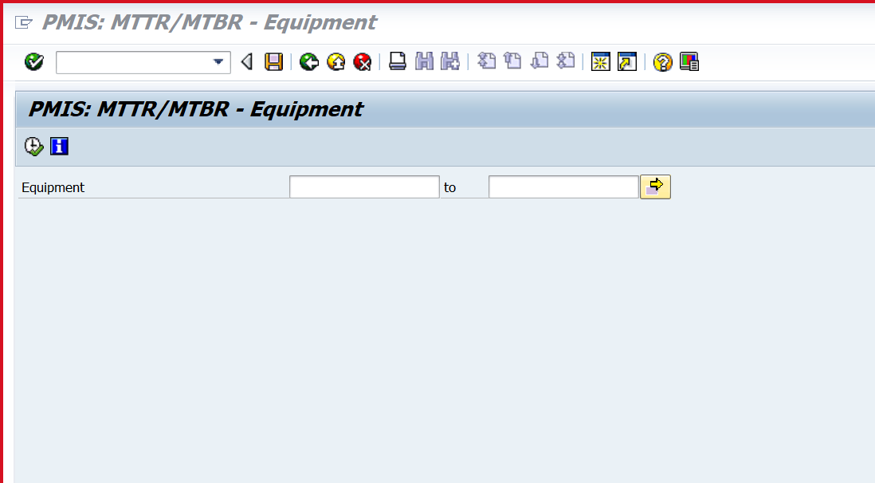

Selection Screen of the Report after enhancement

Period
DD/MM/YYYY
TO
DD/MM/YYYY

Output of the selection Screen

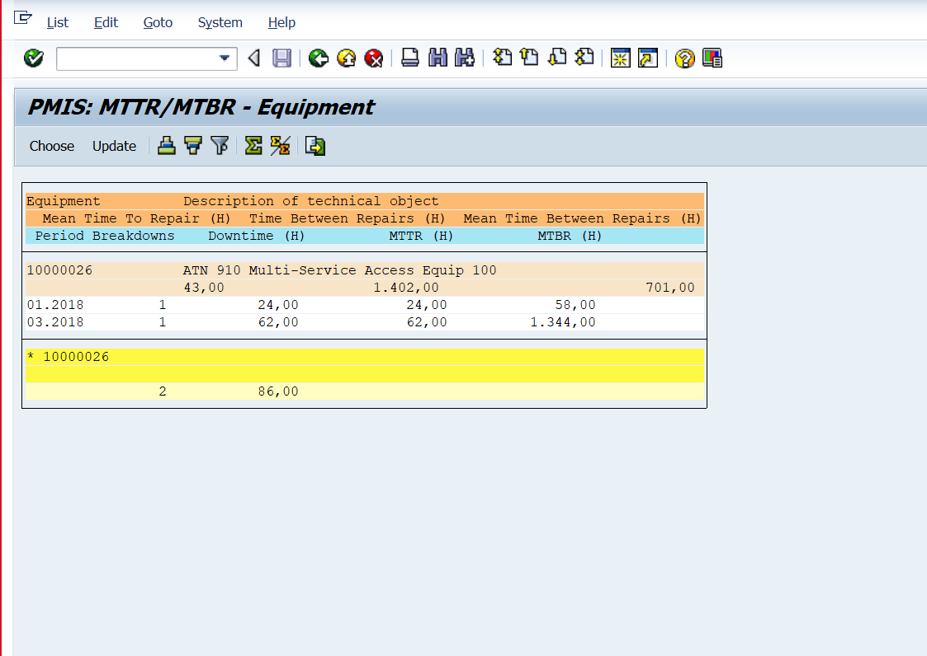

Processing description

Pick the Period Date (ERDAT) from VIQMEL table and put a condition in the program that if From and To date is mentioned in the selection screen the report should fetch the data b/w that period only.

Parameters and configuration

Messages
[Mention if you need and error or information messages for some exceptions]

Message ID | Text | Notes

Security and Authorization
[Mention if any custom authorization or standard authorization need to be checked]

Existing Sample Enhancements
- Program Name:
- Menu / Transaction:
- Related Transactions:

Processing and Operational Considerations

Performance

NA

Batch Requirements

NA

Other

NA

Change Management Requirements

NA

Testing Requirements

Key Business Test Conditions

ID | Condition | Expected results | Cycle Ref.
1
2
3

Technical Test Conditions

ID | Condition | Expected results | Cycle Ref.
1
2

Risk and Controls Test Conditions

ID | Condition | Expected results | Cycle Ref.

Testing Considerations/Dependencies

Additional supporting / reference documentation

Data Impact

Which Master Data or Transactional Data Object is impacted? | Describe the impact on both design/ build | Describe impact on Data Migration Activities (next MOCK cycles) | Resolution | Responsible

Pre-requisites for ‘Reusability’
[Provide details of pre-requisites for making this object reusable. There could be various dependent factors like master data, configuration, typical industry specific scenario etc.]

